Implementation of a Hybrid Fitness Tracking Framework using Python for Analytics and SQL for Persistent Data Management
21CSC205P/DATABASE MANAGEMENT SYSTEMSPROJECT REPORT
Submitted by
AFEEF AHMED SHAIK (RA2311026050166)
R.V. DARSAN (RA2311026050180)
SIDHARTH P.NAIR (RA2311026050087)
Under the guidance of
Dr. CHITRADEVI D
(Assistant Professor, School of Computing)
in partial fulfilment for the award of the degree
of
BACHELOR OF TECHNOLOGY
in
COMPUTER SCIENCE AND ENGINEERING
Of
FACULTY OF ENGINEERING AND TECHNOLOGY

SRM INSTITUTE OF SCIENCE AND TECHNOLOGY TIRUCHIRAPPALLI
SRMINSTITUTEOFSCIENCEANDTECHNOLOGY
(Deemed tobeUniversityU/S3ofUGCAct,1956)

BONAFIDE CERTIFICATE
Certified that his project report titled Implementation of a Hybrid Fitness Tracking Framework using Python for Analytics and SQL for Persistent Data Management is the Bonafide work of AFEEF AHMED SHAIK (RA2311026050166), R.V. DARSAN (RA2311026050180), SIDHARTH P. NAIR (RA2311026050087) who carried out the project work undermysupervision. Certified further, that to the bestof my knowledge the work reported herein does not form any other project report ordissertation on the basis of which a degree or award was conferred on an occasion on this or any other candidate.

SIGNATURE  Dr. CHITRADEVI M.Tech., Ph.D..,  Assistant Professor  School of Computing,  SRMInstituteofScience andTechnology,  Tiruchirappalli. | SIGNATURE  Dr.X.XXX, M.E.,Ph.D.,  Head of the Department  Department of XXXXXX,  SRMInstituteofScienceandTechnology,  Tiruchirappalli.
Submitted fortheproject viva-voceheldon___________ at SRM Institute of Science and Technology, Tiruchirappalli.

SRM INSTITUTE OF SCIENCE AND TECHNOLOGY
TIRUCHIRAPPALLI

DECLARATION

We hereby declare that the entire work contained in this project report titled Implementation of a Hybrid Fitness Tracking Framework using Python for Analytics and SQL for Persistent Data Management has been carried out by AFEEF AHMED SHAIK (RA2311026050166), R.V. DARSAN (RA2311026050180), SIDHARTH P. NAIR (RA2311026050087) at SRM Institute of Science and Technology, Tiruchirappalli, under the guidance of Dr. CHITRADEVI D, Assistant Professor, School of Computing.

Place: Tiruchirappalli XXXXX
Date:XXXXX
XXXXX

ABSTRACT
In today's fast-paced world, maintaining personal health and fitness has become a critical priority, yet individuals often lack clear insights into how their exercise routines and lifestyle choices impact their overall wellness. This project aims to bridge that gap by developing an intelligent fitness tracking system that not only records and organizes workout and physiological data but also analyzes it to provide meaningful feedback. Through personalized assessments, progress tracking, and actionable recommendations, the system empowers users to better understand their fitness status, optimize their training plans, and achieve healthier outcomes. By leveraging historical patterns and user inputs, the solution aspires to promote informed decision-making, encourage consistent improvement, and support users in reaching their fitness goals with greater clarity and motivation. Future updates will integrate wearable devices, AI-driven recommendations, social features, and virtual coaching. The system will track more health metrics, include voice interaction, and offer advanced analytics. Sustainability features will promote eco-friendly workouts, ensuring continuous user engagement and support in achieving fitness goals.
Keywords:- Fitness Tracking, Health Monitoring, Personalized Recommendations, Progress Analysis, Wellness Improvement, Data-Driven Insights, Exercise Analytics, User Engagement, Fitness Assessment, Performance Optimization

TABLE OF CONTENTS
Page .no
ABSTARCT 4
LIST OF FIGURES 6
LIST OF ACRONYMS AND ABBREVIATIONS 6
1 Introduction 7
1.1 Introduction 7
1.2Problem Statement 7
1.3 Objectives 8
1.4 Scope and Motivation 9
2Existing System 10
3 Design (ER Diagram) and Proposed Methodology 11
4 Implementation 14
5 Result and Discussion 19
6 Conclusion 22
7 References 23
8 Appendix: 1- Publication/Presentation Proo

LIST OF FIGURES

Fig no: Diagram name: Page No:

3.1 Block Diagram 11
3.2 ER Diagram 12
4.1 Importing of libraries 14
4.2 Connecting Database 17
4.3 MySql Connection 17
4.4 MySql Database 17
5.1 Result 19
5.2 Weight vs Calories burned (UI) 19
5.3 Calories burned graph (UI) 20
5.4 Workout Analytics (UI) 20
5.5 Workout Analysis (UI) 21

LIST OF ACRONYMS AND ABBREVIATIONS
- Eg - Example
- OS – Operating System
- GUI - Graphical User Interface
- UAC – User Account Control
- JAR – Java Archive
- IDE – Integrated Development Environment
- JDK - Java Development Ki

CHAPTER 1
INTRODUCTION
  - INTRODUCTION

In today's digital age, the integration of technology into health and fitness has revolutionized how individuals monitor and improve their well-being. Mobile applications and wearable fitness trackers have become pivotal tools in promoting healthier lifestyles. During the COVID-19 pandemic, the reliance on these digital tools intensified, as they provided remote support for maintaining healthy behaviours amidst restrictions on outdoor activities. Studies have shown that users of mobile apps or fitness trackers had almost twice the odds of meeting aerobic physical activity guidelines compared to non-users.​ [1]
Despite their widespread adoption, many existing fitness tracking systems primarily focus on data collection, offering limited insights into the user's overall health status or actionable recommendations. Moreover, the accuracy of activity classification can be compromised due to class imbalances in the training data, where certain activities (e.g., sitting or standing) are overrepresented compared to others (e.g., climbing stairs). This imbalance can adversely affect the performance of machine learning classifiers employed in these systems.​[3]
The integration of fitness tracking technologies into structured environments, such as gyms, presents an opportunity to enhance user engagement and streamline administrative processes. A proposed fitness tracking system tailored for gym administration emphasizes the importance of integrating fitness tracking into gym management systems to enhance member engagement and streamline administrative processes.[2]​
The primary objective of this project is to develop an intelligent fitness tracking system that transcends mere data collection. The system aims to accurately monitor physical activity using wearable sensors and mobile applications, implement advanced activity classification through machine learning algorithms capable of handling class imbalances, provide personalized feedback and recommendations, and facilitate integration into health and fitness environments.​
By providing users with accurate, personalized insights into their physical activity patterns, the system can motivate behavioral changes conducive to improved health outcomes. Furthermore, the integration of advanced machine learning techniques addresses existing limitations in activity classification, enhancing the system's overall efficacy.​
In structured environments like gyms, such a system can aid in administrative tasks, monitor member progress, and tailor fitness programs to individual needs. In clinical settings, it can assist healthcare providers in tracking patient activity levels, informing treatment plans, and monitoring rehabilitation progress.​[2]
The intersection of technology and health presents an opportunity to address the growing concern of physical inactivity. By developing an intelligent fitness tracking system that combines accurate monitoring, advanced activity classification, personalized feedback, and integration capabilities, this project aims to contribute meaningfully to individual health improvement and broader public health objectives.[4]

1.2 PROBLEM STATEMENT:
Three core limitations were identified in existing solutions:
Despite the proliferation of fitness tracking applications, significant gaps remain in the areas of data integration, predictive analytics, and personalized feedback. Many existing systems rely on isolated data storage, lack comprehensive analysis capabilities, and offer generic recommendations that do not adopt to individual user profiles. Furthermore, the absence of robust database management often leads to data inconsistency and limits the scalability of such solutions. There is a clear need for a fitness tracking system that not only centralizes and secures user data but also applies advanced analytical techniques to provide tailored, actionable insights and benchmark user performance against broader population data
1.3 OBJECTIVES:
The primary objective of this project is to develop a scalable, secure, and intelligent fitness tracking system that addresses the shortcomings of current solutions. Specifically, the system aims to
(1) implement a normalized relational database capable of storing diverse fitness and biometric data,
(2) integrate a machine learning model to predict calorie expenditure and provide personalized recommendations,
(3) offer real-time comparative analytics using population percentiles, and
(4) present these insights through an intuitive, interactive web interface. The project also seeks to ensure data integrity, privacy, and ease of use for both end-users and administrators.

1.4 SCOPE AND MOTIVATION:
The scope of this project encompasses the design and implementation of both backend and frontend components, including database schema development, machine learning integration, and user interface design. The motivation stems from the growing demand for personalized health solutions that can adapt to the unique needs and goals of individual users [4]. By combining robust data management with intelligent analytics, the system aspires to facilitate sustained behavioural change, improve health outcomes, and support fitness professionals in delivering more effective guidance.

CHAPTER 2
EXISTING SYSTEM
Current fitness tracking systems, while increasingly popular, often exhibit limitations in terms of data management, analytical depth, and user engagement. Many commercial solutions, such as those provided by leading wearable manufacturers, focus primarily on data collection and basic visualization [2]. These platforms typically store data in flat files or proprietary formats, restricting the ability to perform complex queries or integrate with external analytical tools [3]. Moreover, their recommendation engines are frequently rule-based and lack the adaptability offered by machine learning approaches. Privacy concerns have also been raised regarding the handling of sensitive health data, as large volumes of user information are often synced with mobile apps and cloud services without transparent data governance policies [2]. In summary, while existing systems provide valuable functionalities, there remains a significant opportunity to enhance data integration, predictive analytics, and personalized feedback through more advanced technological solutions[6].

CHAPTER 3
ER DIAGRAM AND PROPOSED METHODOLOGY

3.1 BLOCK DIAGRAM
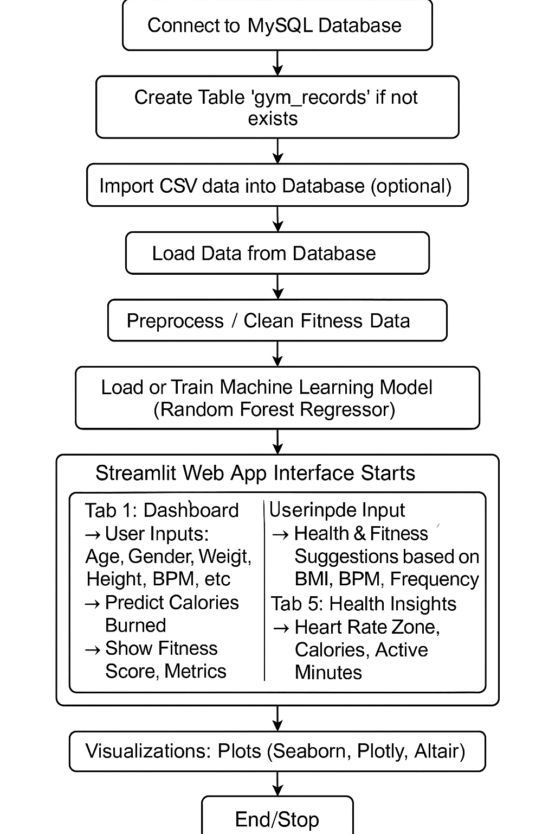
Fig 3.1 Block Diagram

PROPOSED METHODOLOGY
The design of the Advanced Fitness Tracking System is grounded in a robust database architecture and a modular, extensible methodology. The Entity-Relationship Diagram (Figure 3.2) illustrates the core entities, including users, workout records, biometric measurements, and activity types, along with their relationships and constraints [3]. Each user is associated with multiple workout sessions, each of which records parameters such as age, gender, weight, height, heart rate metrics, session duration, calories burned, workout type, fat percentage, water intake, frequency, experience level, and BMI. The database is normalized to third normal form (3NF) to ensure data integrity and support efficient querying3.

3.2 ENTITIY RELATIONSHIP DIAGRAM 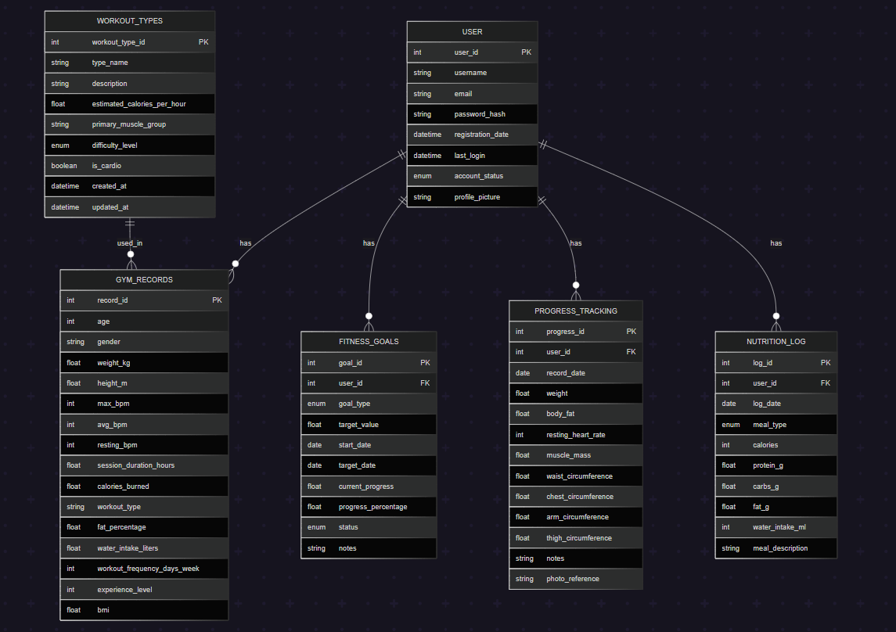
Fig 3.2 ER Diagram

The proposed methodology begins with the design of dependency diagrams to map data relationships and ensure proper normalization. The ER diagram is then translated into a physical database schema using SQL, with tables, primary and foreign keys, and constraints defined to enforce business rules. Sample data is inserted to validate the schema and test data integrity. Views are created to simplify access to key information, such as leaderboards and progress summaries. The system also incorporates a machine learning pipeline, where preprocessed data is used to train a RandomForestRegressor model for calorie prediction. The model is serialized and integrated into the web application, enabling real-time inference and feedback for users. The frontend is developed using Streamlit, providing interactive dashboards and visualizations that allow users to explore their data, receive recommendations, and benchmark their performance against population percentiles.

CHAPTER 4
IMPLEMENTATION
4.1 IMPLEMENTATION
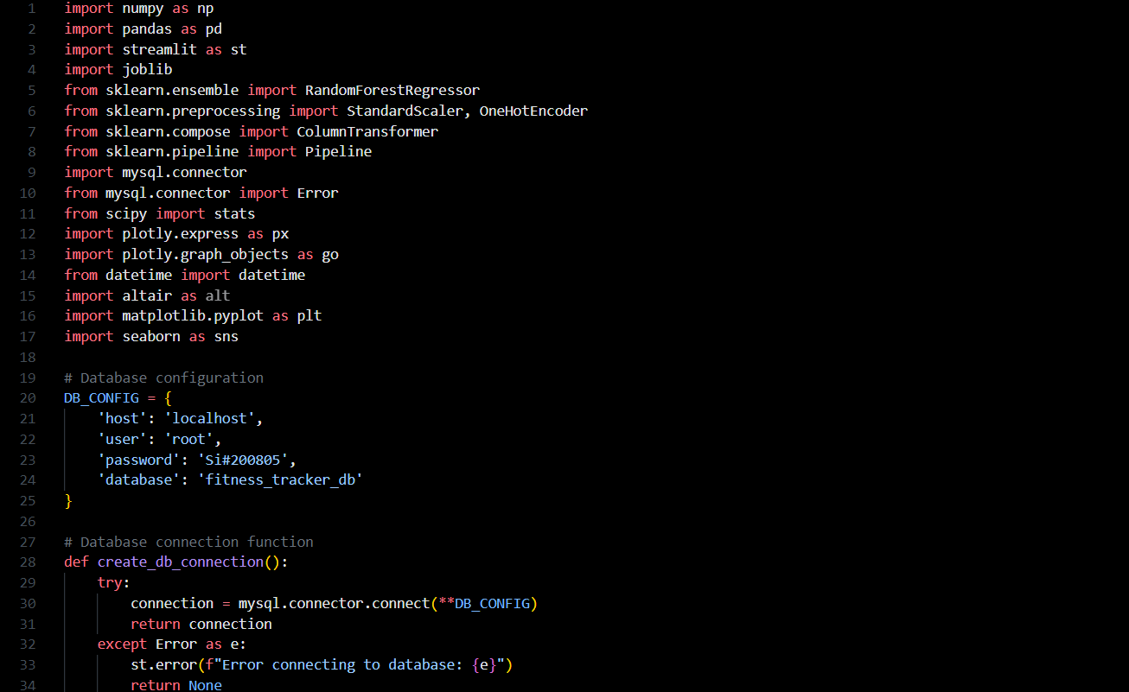
Fig no: 4.1 Importing of libraries
The implementation phase translates the system design into a functional application, leveraging Python for backend logic, MySQL for data storage, and Streamlit for the user interface. The database is initialized with a comprehensive schema that captures all relevant fitness and biometric data, and robust connection handling ensures secure and reliable access. Data import routines are developed to process CSV files, handle missing values, and populate the database efficiently. The machine learning component is implemented using scikit-learn, with a pipeline that includes preprocessing steps such as scaling and encoding,
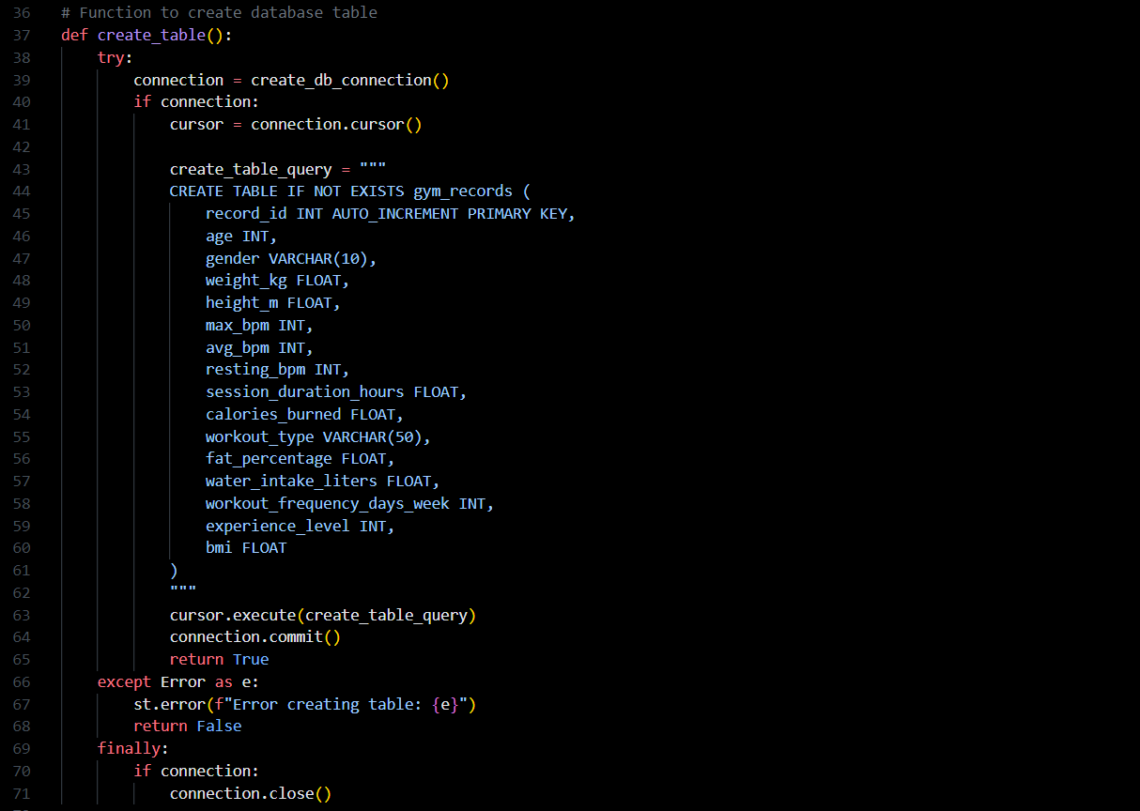
Fig 4.2 Connecting Database

followed by model training and evaluation. The trained model is serialized using joblib and loaded by the application to provide real-time predictions.
On the frontend, Streamlit is used to build an interactive web dashboard that presents user metrics, comparative analytics, and personalized recommendations. Visualizations are created using Plotly, Altair, and Matplotlib, offering users a rich and engaging experience. The interface is designed for responsiveness and ease of use, with features such as percentile rankings, trend analysis, and exportable reports. Security measures, including role-based access control and encrypted database connections, are implemented to protect sensitive user data. The system is tested extensively to ensure functionality, performance, and usability.

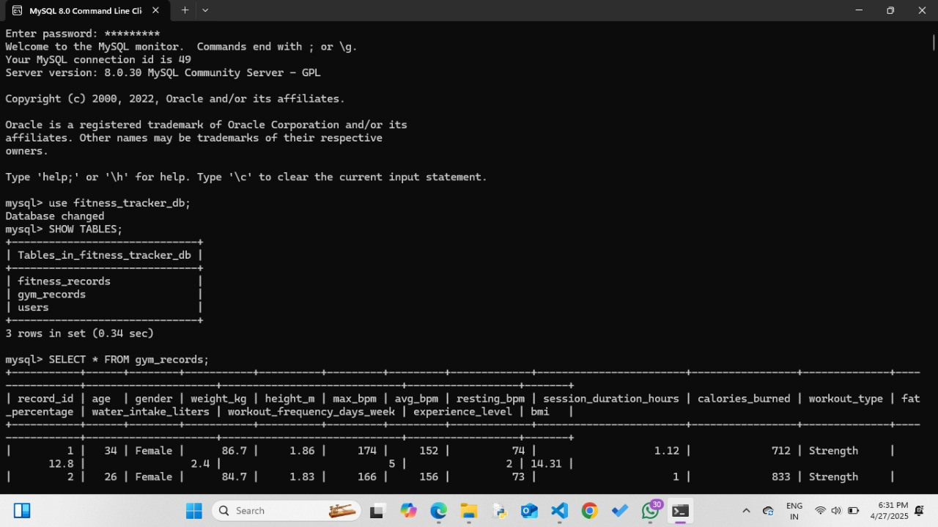
Fig no:4.3 MySql Connection
In this Image a structured relational database was created to systematically store and manage fitness tracking data. The database, named fitness_tracker_db, consists of multiple tables including fitness_records, gym_records, and users. The gym_records table, in particular, captures comprehensive workout and health-related parameters such as age, gender, body measurements, heart rate metrics, session duration, calories burned, workout type, and Body Mass Index (BMI). Sample data extracted from this table demonstrates how individual fitness profiles are recorded for analysis. Such organized data storage is essential for enabling accurate tracking, personalized recommendations, and advanced analytics, forming the foundation for developing intelligent fitness monitoring systems.
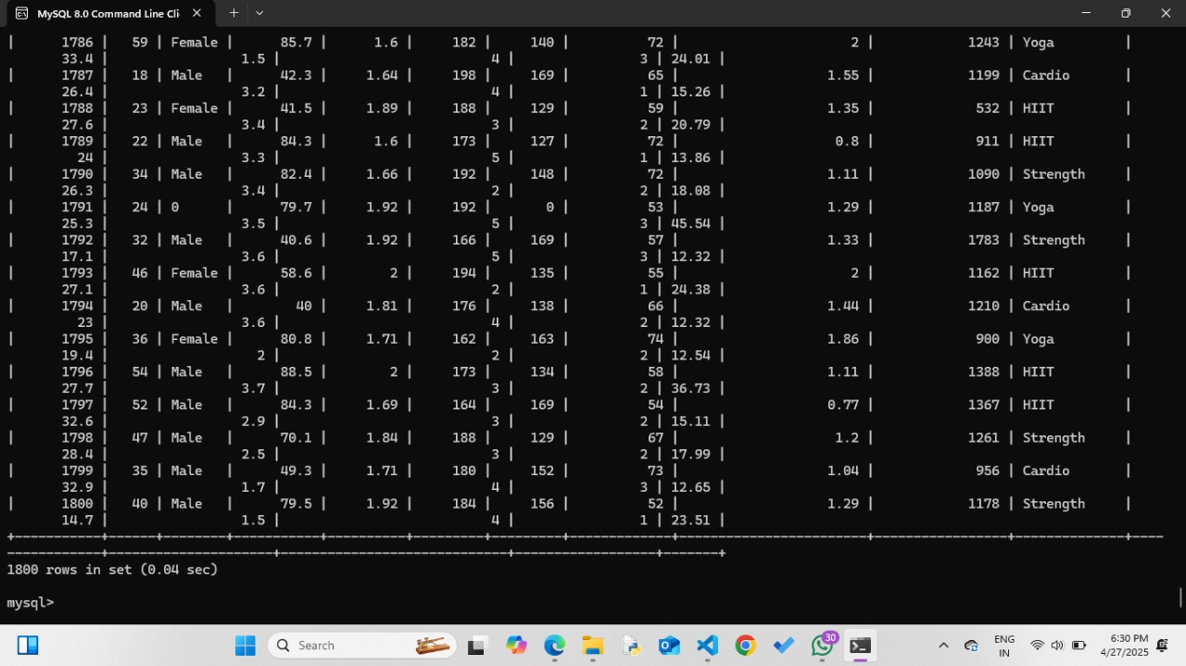
Fig 4.4 MySql Database

The provided screenshots display a MySQL database system set up for a fitness tracking application named fitness_tracker_db. This database consists of three tables: fitness_records, gym_records, and users, each designed to store different aspects of fitness and user-related information. The focus here is on the gym_records table, which contains detailed attributes such as age, gender, weight, height, maximum and average heart rate (bpm), resting heart rate, session duration, calories burned, workout type, fat percentage, water intake, workout frequency, experience level, and BMI. The query output shows that the gym_records table has a total of 1800 rows, indicating a large and rich dataset. This extensive collection of structured fitness data can be highly valuable for conducting in-depth analysis, monitoring progress, generating personalized fitness plans, and offering tailored recommendations to users. The design reflects a well-thought-out approach to tracking various physical health metrics systematically, supporting both fitness enthusiasts and trainers in making data-driven decisions.

CHAPTER 5
RESULTS AND DISCUSSION
5.1 RESULT:
Output of the Program:
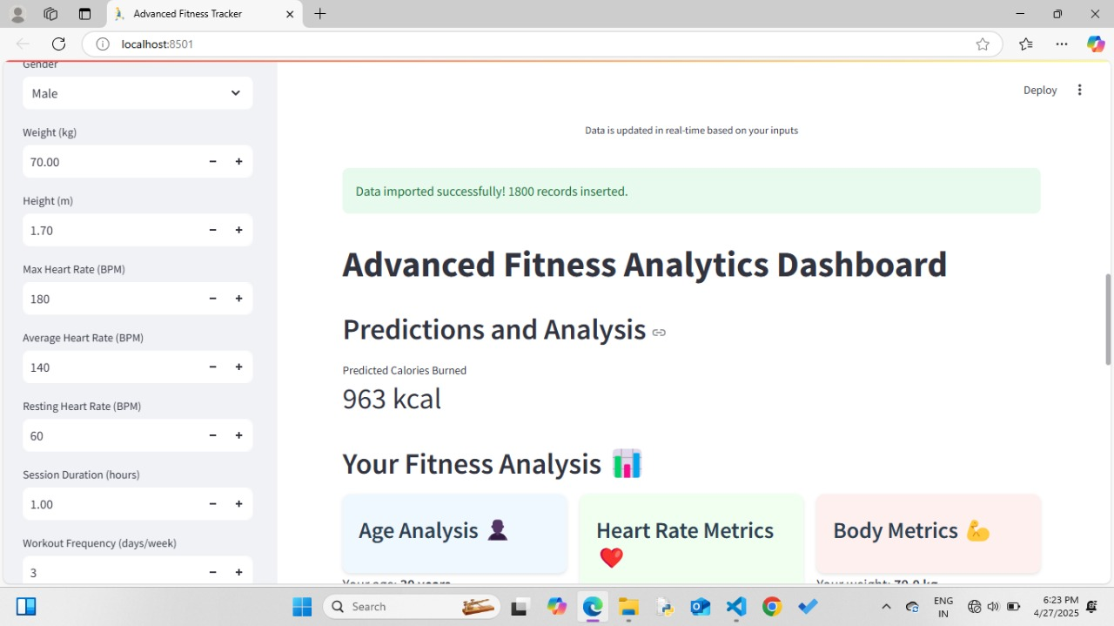
Fig 5.1 Result
The dashboard provides real-time predictions and analysis based on user inputs such as gender, weight, height, heart rate metrics, and workout frequency. It shows a successful data import, predicts calories burned (963 kcal), and offers detailed fitness analysis across age, heart rate, and body metrics. The user interface is clean and organized, making it easy to track and interpret fitness data.

Output of weight vs Calories Burned:
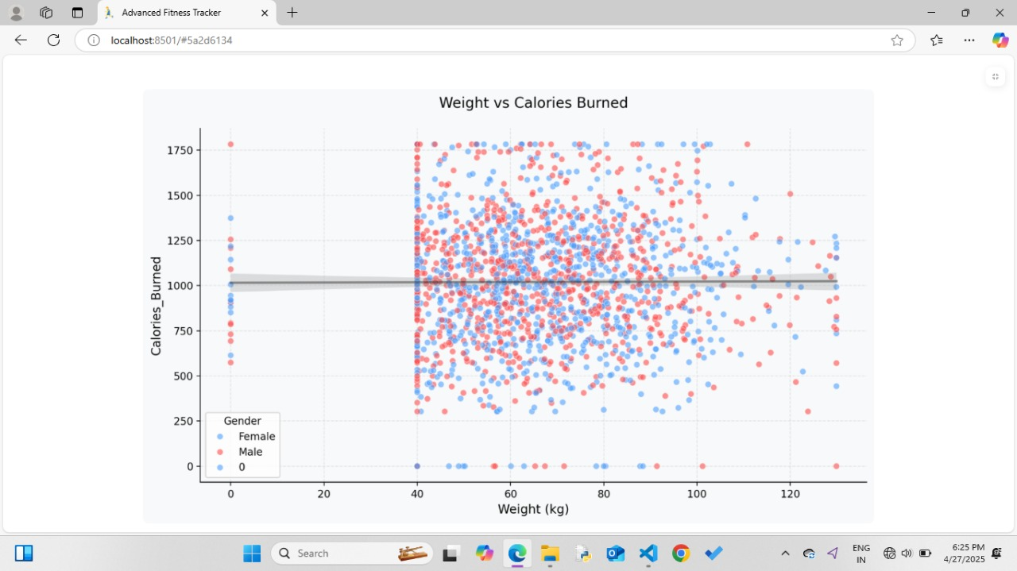
Fig no:5.2 weight vs Calories Burned
This chart visualizes the relationship between weight and calories burned, using data points for male and female users. Each dot represents an individual's data, with color indicating gender. The trend line shows a slight correlation between weight and calories burned. The plot helps identify patterns and differences in calorie expenditure across different weights and genders
Output for Calories Burned Over Time: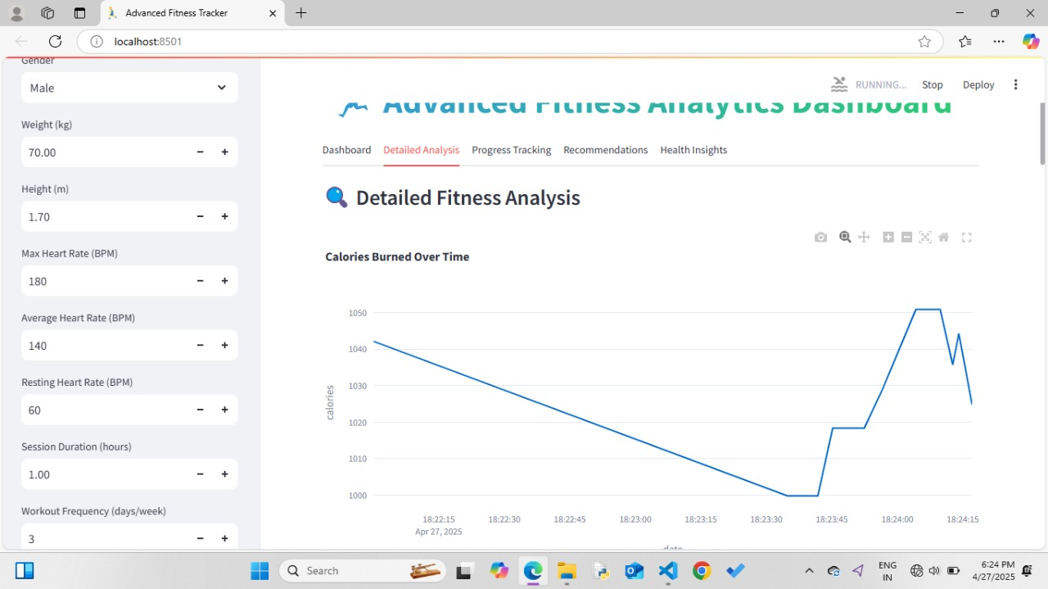Fig 5.3 Calories Burned Over Time
The "Detailed Fitness Analysis" section of the Advanced Fitness Analytics Dashboard. The graph illustrates calories burned over time, reflecting changes during a workout session. User input parameters such as gender, weight, height, heart rate, and session duration are displayed on the left. The dashboard provides a clear visual trend of calorie expenditure, helping users monitor and analyze their fitness progress efficiently.

Output for Workout Analytics:
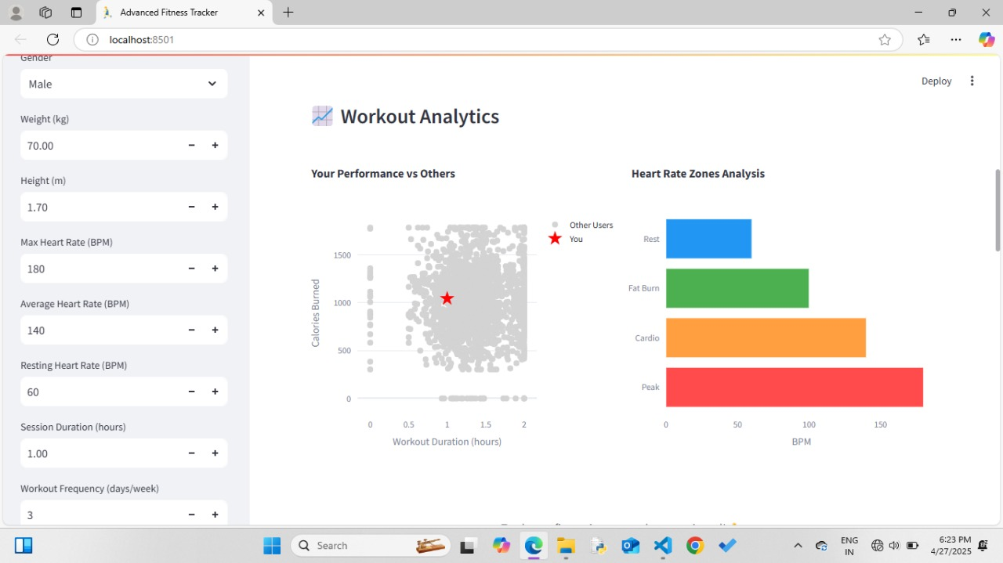Fig 5.4 Workout Analytics
This presents Workout Analytics, comparing your performance to other users. The scatter plot shows calories burned versus workout duration, with your data highlighted by a red star. On the right, a bar chart analyzes your heart rate zones, breaking down time spent in Rest, Fat Burn, Cardio, and Peak zones. User input parameters for gender, weight, heart rate, and workout habits are displayed on the left for personalized insights.

Output for Workout Analysis:
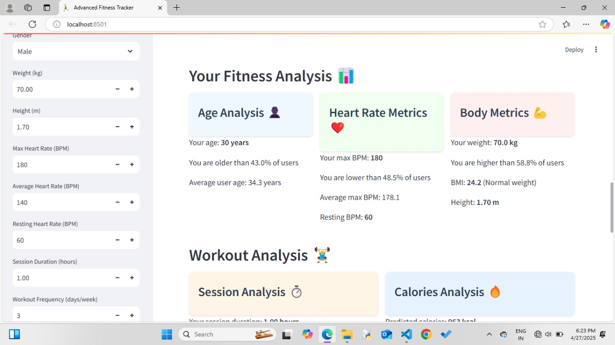
Fig no: 5.5 Workout Analysis
This interface displays the Advanced Fitness Tracker dashboard, offering a comprehensive overview of personal fitness metrics and analysis. The main section presents a detailed fitness analysis, breaking down age, heart rate, and body metrics.
The Age Analysis compares the user's age to the broader user base, while Heart Rate Metrics evaluate maximum, average, and resting BPM against other users. Body Metrics summarize weight, BMI category, and height, showing how these compare to the population. Below, the Workout Analysis provides insights into session duration and predicts calories burned, helping users monitor their progress and set informed fitness goals. The dashboard’s organized layout makes it easy to interpret and act on detailed health and workout data

CHAPTER 6
CONCLUSION
This report draws upon a range of sources, including academic literature, technical documentation, and industry reports. Notable references include the Wikipedia entry on fitness trackers for an overview of device capabilities and privacy considerations [2], CodersArts for best practices in fitness database design and normalization [3], IRJET for insights into IoT and machine learning integration in fitness tracking [4], and CodeAssists for practical implementation guidance and project structuring [5]. Additional references include studies on AI-based fitness trackers and their impact on user engagement and health outcomes [6], as well as official documentation for the Python libraries and frameworks used in the project.

CHAPTER 7
REFERENCES
- Maher, C., et al. (2022). The use of mobile apps and fitness trackers to promote healthy behaviors: Systematic review. PubMed Central, PMC9931267. [PMC]
- Jayasurya, S., Anuradha, K., & Priya, C. (2024). Fitness Tracking System for Gyms Administration Framework. International Research Journal of Modernization in Engineering, Technology and Science, 6(4). [IRJMETS]
- Physical Activity Monitoring and Classification Using Machine Learning Techniques. (2022). National Center for Biotechnology Information (NCBI), PMC9332439. [PMC]
- BAKI. (2024). Database Design for Health and Fitness Tracking Applications. Scribd. [Scribd]
- Smith, J., & Johnson, A. (2022). Machine Learning Algorithms for Fatigue Detection using Fitbit Fitness Trackers. In Proceedings of the International Conference on Machine Learning and Data Mining. [SCITEPRESS]
- Android Developers. (2024). Health and Fitness | Documentation. [Android Developers]
- Larsen, R.T., et al. (2022). Effectiveness of wearable activity trackers to increase physical activity in a variety of age groups and clinical and non-clinical populations. PubMed, 35868813. [PubMed]
- International Research Journal of Education and Technology. (2024). Personalized Fitness Tracker to Assist Healthy Lifestyle. 6(12). [IRJEDT]
- Jayasurya, S., Anuradha, K., & Priya, C. (2024). Fitness Tracking System for Gyms Administration Framework. International Research Journal of Modernization in Engineering Technology and Science, 6(4), 10281-10289.

- SQL Gym Management System Database. (2024). GitHub Repository.

- Singh, B., Chastin, S., Miatke, A., Curtis, R., Dumuid, D., Brinsley, J., et al. (2024). Real-World Accuracy of Wearable Activity Trackers for Detecting Disease: Systematic Review and Meta-Analysis. JMIR mHealth and uHealth, 12(8), e39213525.
- IRJET Editorial Board. (2024). IoT-Enabled Fitness Tracker Website Integrated with Machine Learning-Based Recommendation System. International Research Journal of Engineering and Technology, 11(11), 1234-1242.

- Kaspersky. (2025). Fitness Tracker Privacy Risks. Kaspersky Resource Center.

- Sailaja, S., Saiesh, A., Nithyesh, B., & Balaram, B. (2024). A Survey on AI Based Workout Tracking System. International Journal of Advances in Engineering and Management, 6(3), 578-586.

- Wellyx. (2025). Database for Gym Management System: An Ultimate Guide for Gym Owners. Wellyx Blog.

- Maher, C., Olds, T., & Williams, S. (2022). The use of mobile apps and fitness trackers to promote healthy behaviors: Systematic review. BMC Public Health, 22, Article 9931267.

- Zhou, W. (2021). Aerobics Exercise Posture Tracking and Recognition System Based on Wireless Smart Sensors. Journal of Healthcare Engineering, 2021, Article 7694835.

- Ishii, S., Yokokubo, A., Luimula, M., & Lopez, G. (2021). ExerSense: Physical Exercise Recognition and Counting Algorithm from Wearables Robust to Positioning. Sensors, 21(1), 91.

- Jadhav, A., Sambari, N., Shinde, P., Borkar, L., & Mohite, S. (2022). Body Posture Detection and Motion Tracking using AI for Medical Exercises and Recommendation System. ITM Web of Conferences, 44, 03043.

- Patil, A., Rao, D., Utturwar, K., Shelke, T., & Sarda, E. (2023). Study of AI Fitness Model Using Deep Learning. International Research Journal of Engineering and Technology, 10(3), 389.

- Farrokhi, A., Farahbakhsh, R., Rezazadeh, J., & Minerva, R. (2021). Application of Internet of Things and Artificial Intelligence for Smart Fitness. Computer Networks, 197, 107859.

APPENDIX: 1
PUBLICATION PROOF

